3rd ANNUAL Town of Cedar Bluff
Christmas Parade
Sponsored by the Town of Cedar Bluff
Monday, December 9, 2019
Parade begins: 6:00 pm

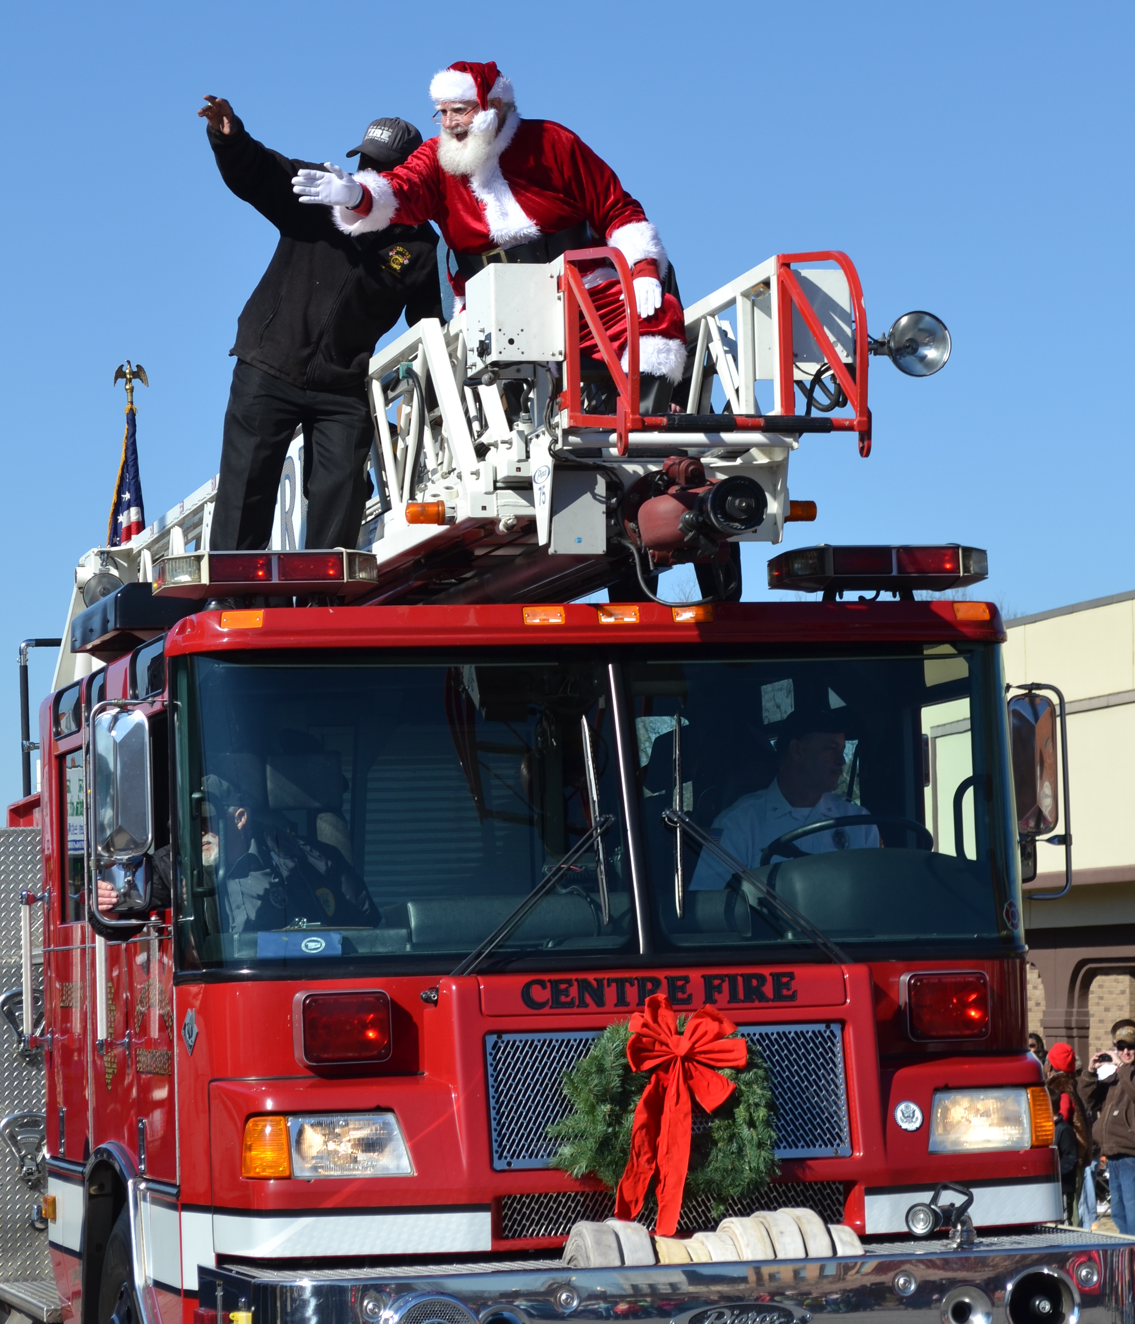

Line-up @ 5:00pm

Rules:
* Only One Santa -designated by Parade Committee

*No more than 2 individuals are allowed to ride on hood or seat-back of one car.

*If children are riding on a float, there must be adults walking beside float or riding on float for protection
and safety of the children.

*All floats should have escort vehicles to and from the parade line up for safety.

*No fee to be in parade.

Name: ________________________________________________________________
Name of Business/Municipality, Civic/Non-Profit, and Schools

Address ______________________________________________________________

E-mail_________________________________________________________________

Contact person: _________________________ or ____________________________

Phone: home/business ______________________ or cell_______________________

Type of Entry: Float ______ Category: _____Business/Municipality ____Civic/Non-Profit ____School

Car or truck ______ Truck/trailer_______ Walking _________ Band __________ Horse________

Other (specify) _______________________

Email: townclerkassist@gmail.com or Fax to 256-779-6148 or call 256-779-6121 for questions
Mail to Town of Cedar Bluff, P.O. Box 38 Cedar Bluff, Alabama 35959

Forms should be turned in no later than Monday, Dec. 2nd

