Trunk or Treat 2017
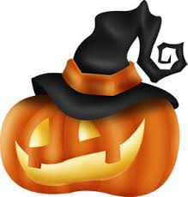
Sponsored by Cedar Bluff Police Department

Tuesday, October 31st, 2017
5:00 PM-9:00 PM
Cedar Bluff Town Park

Name of Organization:___________________________________
Contact Person:___________________________________________
Contact Number:__________________________________________

